**Institute of Technology Tralee**

**BSc. in Computing with Specialism (Group 2) - Year 1**

**Continuous Assessment #1**

**Date: 3/11/14**

**Time: 1 – 3 p.m.**

**Introduction to Programming**

**Instructions:** Attempt the following question. You should use the JCreator IDE for coding. When you are finished you must print out your code for correction.

**________________________________________________________**

**Q1.**

Write a Java program that first of all reads in the value of an angle in degrees (this can be a fractional number). We will say for the purposes of this program that all valid angles are those between zero and 360 degrees **inclusive**. Should the user enter a value outside of this range then the program should issue an error message and the program should then terminate immediately and do no other processing whatsoever.

However, if the user enters an angle within the acceptable range, then a suitable message should be issued to indicate the type of angle in question based on the following table:

|  |  |
| --- | --- |
| **Angle in Degrees** | **Type of Angle** |
| Less than 90 degrees | Acute angle |
| Exactly 90 degrees | Right angle |
| Greater than 90 degrees but less than 180 degrees | Obtuse angle |
| Exactly 180 degrees | Straight angle |
| Greater than 180 degrees | Reflex angle |

To finish, the program should then display (only for valid angles) the equivalent angle in radians. The formula that relates angles in degrees and radians is as follows:

$$radians= \frac{2π(degrees)}{360}$$

Where you can take $π$ to be the number 3.142. The angle in radians should then be displayed correct to **2 decimal places**.

Using the test values as indicated in the screen shots below, the program should give you **exactly** the following output when it runs, including banners, blank lines, units etc. Note the banner is **tabbed** twice here.

Also note that there will be a few marks awarded for the use of **meaningful variable names**, having a **single and multi-line comment at the top of the program** and for **proper indentation** in the coding of the program.

**Sample Screen Shots**

**The user enters an invalid angle here**

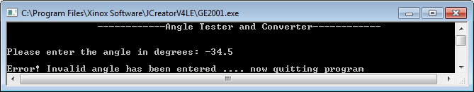

**The user enters an invalid angle here**

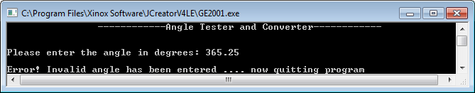

**The user enters an acute angle here**

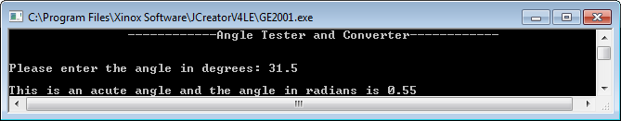

**The user enters a right angle here**

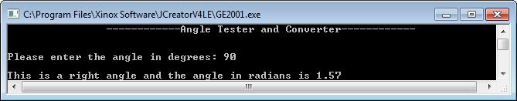

**The user enters an obtuse angle here**

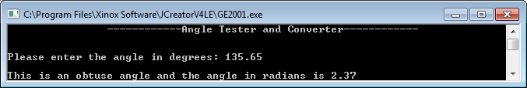

**The user enters a straight angle here**

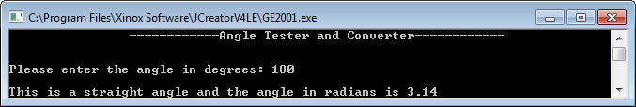

**The user enters a reflex angle here**

